

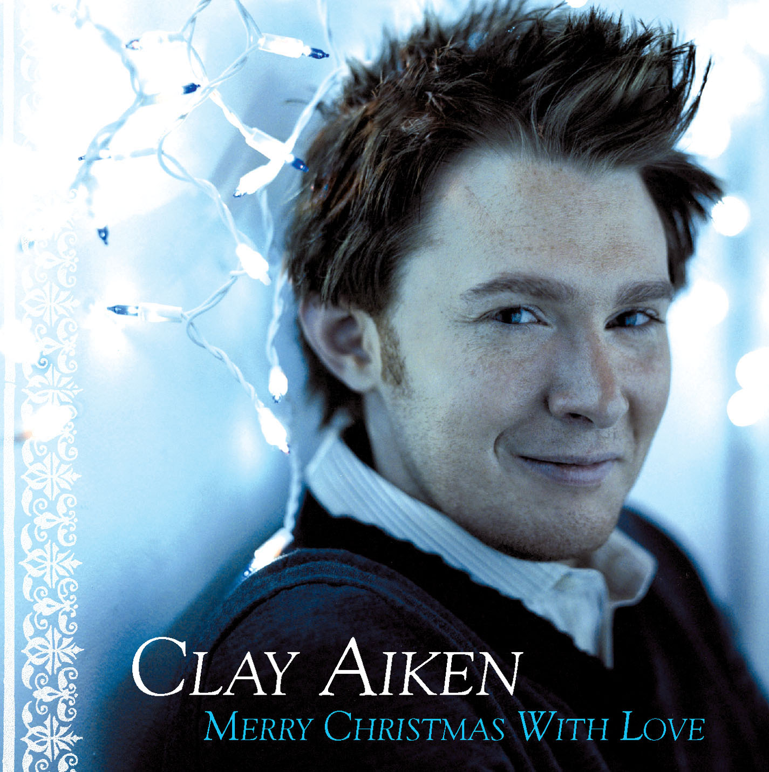

compiled by cha cha
claymatized.com
1

O Holy Night

O holy night! The stars are brightly shining,
It is the night of the dear Saviour's birth.
Long lay the world in sin and error pining.
Till He appeared and the soul felt its worth.

A thrill of hope, the weary soul rejoices,
For yonder breaks a new and glorious morn.
Fall on your knees! Oh, hear the angel voices!
O night divine, oh night when Christ was born;
O night, oh holy night, oh night divine.

A thrill of hope, the weary world rejoices,
For yonder breaks a new and glorious morn.
Fall on your knees! Oh, hear the angel voices!
O night divine, oh night when Christ was born;
O night, oh holy night, oh night divine.

2
Winter Wonderland

Sleigh bells ring, are you listenin'
In the lane, snow is glistenin'
A beautiful sight
We're happy tonight
Walkin' in a winter wonderland.

Gone away is the bluebird
Here to stay is a new bird
He sings a love song
As we stroll along
Walkin' in a winter wonderland.

In the meadow we can build a snowman
And pretend that he is Parson Brown
He'll say "Are you married?", we'll say "No, man,
But you can do the job when you're in town."

Later on, we'll conspire
As we dream by the fire
To face unafraid
The plans that we've made
Walkin' in a winter wonderland.

Sleigh bells ring, are you listenin'
In the lane, snow is glistenin'
A beautiful sight
We're happy tonight
Walkin' in a winter wonderland.

In the meadow we can build a snowman
And pretend that he is a circus clown
We’ll have lots of fun with Mr. Snowman
Until the other kiddies knock him down

When it snows, ain’t it thrillin
Though your nose gets a chillin
We’ll frolic and play
The Eskimo way
Walkin’ in a winter wonderland.
Walkin’ in a winter wonderland.
Walkin’ in a winter wonderland.

3

Silent Night

silent night, holy night
all is calm, all is bright
round yon virgin mother and child
holy infant so tender and mild
sleep in heavenly peace
sleep in heavenly peace

silent night, holy night
shepherds quake at the sight
glories stream from heaven afar
heavenly hosts sing alleluia
Christ the savior is born
Christ the savior is born

silent night, holy night
son of god
love's pure light
radiant beams from thy holy face
with the dawn of redeeming grace
Jesus lord at thy birth
Jesus lord at thy birth

Jesus lord at thy birth
Jesus lord at thy birth

sleep in heavenly peace
sleep in heavenly peace

4
Hark The Herald Angels Sing

Hark the herald angels sing
"Glory to the new born King
Peace on earth and mercy mild ,
God an sinners reconciled"
Joyful all ye nations rise.
Join the triumph of the skies
With angelic host proclaim
"Christ is born in Bethlehem"

Christ, by highest heaven adored;
Christ the everlasting Lord;
Late in time behold him come,
Offspring of a virgin’s womb.
Veiled in flesh, the Godhead see;
hail the incarnate Diety
Pleased as man with men to dwell,
Jesus, our Immanuel
Hark the herald angels sing, Glory to the new born

O Come all ye faithful
Joyful and triumphant
O come ye o come ye
To Bethlehem

Come and behold him
Born the King of Angels
Oh come let us adore him
Oh come let us adore him
Oh come let us adore him
Christ the lord

O Come all ye faithful
Joyful and triumphant
O come ye o come ye
To Bethlehem

Come and behold him
Born the King of Angels
Oh come let us adore him
Oh come let us adore him
Oh come let us adore him
Christ the lord

5
Have Yourself A Merry Little Christmas

Have yourself a merry little Christmas
Let your heart be light
From now on all troubles will be out of site
Have yourself a merry little Christmas
Make the yuletide gay
From now on all troubles will be miles away
Here we are as in olden days
Happy golden days of your
Faithful friends who are dear to us
Gather near to us once more
Through the years we all will be together
If the fates allow
Hang a shining star upon the highest bow
And have yourself a merry little Christmas

Here we are as in olden days
Happy golden days of your
Faitful friends who are dear us
Gather near to us once more
Through the years we all will be together
If the fates allow
Hanging a shining bow upon the highest bow
And have yourself a merry little Christmas now

6
Mary, Did You Know?

Mary, did you know
that your Baby Boy would one day walk on water?
Mary, did you know
that your Baby Boy would save our sons and daughters?
Did you know
that your Baby Boy has come to make you new?
This Child that you delivered will soon deliver you.

Mary, did you know
that your Baby Boy will give sight to a blind man?
Mary, did you know
that your Baby Boy will calm the storm with His hand?
Did you know
that your Baby Boy has walked where angels trod?
When you kiss your little Baby you kissed the face of God?

Mary did you know.. Ooo Ooo Ooo

The blind will see.
The deaf will hear.
The dead will live again.
The lame will leap.
The dumb will speak
The praises of The Lamb.

Mary, did you know
that your Baby Boy is Lord of all creation?
Mary, did you know
that your Baby Boy will one day rule the nations?
Did you know
that your Baby Boy is heaven's perfect Lamb?
The sleeping Child you're holding is the Great, I Am.

7
Joy To The World

Joy to the world
The Lord is come
Let earth receive her King
Let every heart prepare Him room
And heaven and nature sing
And heaven and nature sing
And heaven and heaven and nature sing

Joy to the earth
The Savior reigns
Let men their songs employ
While fields and floods
Rocks, hills, and plains
Repeat the sounding joy
Repeat the sounding joy
Repeat, repeat the sounding joy

No more let sins and sorrows reign,
Nor thorns infest the ground;
He comes to make His blessing flow
For as the curse is found,
For as the curse is found,
For as, for as the curse is found.

He rules the world
With truth and grace
And makes the nations prove
The glories of His righteousness
And wonders of His love
And wonders of His love
And wonders, and wonders of His love
And wonders, and wonders of His love

8
The Christmas Song

Chestnuts roasting on an open fire
Jack Frost nipping at your nose
Yuletide carols being sung by a choir
And folks dressed up like Eskimos
Everybody knows that turkey and some mistletoe
Can help to make the season bright
Tiny tots with their eyes all a-glow
Will find it hard to sleep tonight

They know that Santa's on his way
He's loading lots of toys and goodies on his sleigh
And every mother's child is gonna spy
To see if reindeer really know how to fly

And so, I'm offering this simple phrase
To kids from one to ninety-two
Although it's been said many times, many ways
Merry Christmas to you

They know that Santa's on his way
He's loading lots of toys and goodies on his sleigh
And every mother's child is gonna spy
To see if reindeer really know how to fly

And so, I'm offering this simple phrase
To kids from one to ninety-two
Although it's been said many times, many ways
Merry Christmas to you

And every mother's child is gonna spy
To see if reindeer really know how to fly

And so, I'm offering this simple phrase
To kids from one to ninety-two
Although it's been said many times, many ways
Merry Christmas to you

9

Don't Save It All for Christmas Day

Don't get so busy that you miss
Giving just a little kiss
To the ones you love
Don't even wait a little while
To give them just a little smile
A little is enough

How many people in this world
Some people are dying
How many people are asking for love

~chorus~
So don't save it all for Christmas day
Find a way
To give a little love every day
Don't save it all for Christmas day
Find a way
'Cause holidays have come and gone
But love lives on
If you give on
Love

How could you wait another minute?
A hug is warmer when you're in it
Oh, baby that's a fact
And saying I love you's always better
Seasons, reasons they don't matter
So don't hold back

How many people in this world
So needful in this world
How many people are praying for love

~repeat chorus~
Don't save it all for Christmas Day
Find a way
To give a little love everyday
Don't save it all for Christmas Day
Find your way
Cause holidays have come and gone
But love lives on
If you give on
Give love...

Let all the children know
Everywhere that they go
Their whole life long
Let them know love

10
Merry Christmas with love

She leaned with her head on the window
Watching evergreen bend in the snow
Remembering Christmas the way it had been
So many seasons ago.

When children would reach for their stockings
And open the presents they found
The lights on the tree would shine bright in their eyes
Reflecting the love all around.

This year there's no one to open the gifts
No reason for trimming the tree
And just as a tear made its way to the floor
She heard voices outside start to sing.

Merry Christmas to all who may dwell here
Merry Christmas if even just one
May the joy of the season surround you
Merry Christmas with love.

Carolers sang as she opened the door
Faces of friends in the crowd
And all of the shadows of lonely reminders
Driven away by the sound.

Now the heart that for years had been silent
Was suddenly filled with a song
As she clung to their hands like a child in the night
She found her self singing along.

Merry Christmas to all who may dwell here
Merry Christmas if even just one
May the joy of the season surround you
Merry Christmas.

Merry Christmas to all who may dwell here
Merry Christmas if even just one
May the joy of the season surround you
Merry Christmas with love

11
Sleigh Ride

Just hear those sleigh bells jingling, ring-ting-tingling, too.
Come on, it's lovely weather for a sleigh ride together with you.
Outside the snow is falling and friends are calling, "Yoo-hoo!"
Come on, it's lovely weather for a sleigh ride together with you.

Giddy-yap, giddy-yap, giddy-yap, let's go,
Let's look at the show
We're riding in a wonderland of snow.
Giddy-yap, giddy-yap, giddy-yap, it's grand,
Just holding your hand.

We're gliding along with a song of a wintery fairyland.
Our cheeks are nice and rosy and comfy-cozy are we.
We're snuggled up together like two birds of a feather would be.
Let's take that road before us and sing a chorus or two.
Come on, it's lovely weather for a sleigh ride together with you.

There's a birthday party at the home of Farmer Gray.
It'll be the perfect ending of a perfect day.
We'll be singing the songs we love to sing without a single stop,
At the fireplace while we watch the chestnuts pop. Pop! Pop! Pop!

There's a happy feeling nothing in the world can buy,
When they pass around the turkey and the pumpkin pie.
It'll nearly be like a picture print by Currier and Ives.
These wonderful things are the things we remember all through our lives!

Just hear those sleigh bells jingling, ring-ting-tingling, too.
Come on, it's lovely weather for a sleigh ride together with you.
Outside the snow is falling and friends are calling, "Yoo-hoo!"
Come on, it's lovely weather for a sleigh ride together with you.

12
What Are You Doing New Year's Eve?

Maybe it's much too early in the game
Ooh, but I thought I'd ask you just the same
What are you doing New Year's
New Year's eve?

Wonder whose arms will hold you good and tight
When it's exactly twelve o'clock that night
Welcoming in the New Year
New Year's eve

Maybe I'm crazy to suppose
I'd ever be the one you chose
Out of the thousand invitations
You received

Ooh, but in case I stand one little chance
Here comes the jackpot question in advance:
What are you doing New Year's
New Year's Eve?

Maybe I'm crazy to suppose
I'd ever be the one you chose
Out of the thousand invitations
You received

Ooh, but in case I stand one little chance
Here comes the jackpot question in advance:
What are you doing New Year's
New Year's Eve?

